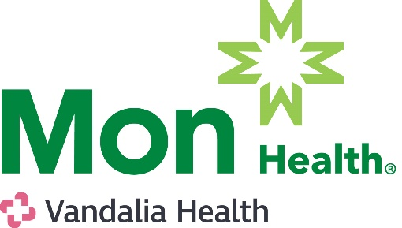
PATIENT INFORMATION
DIRECT ACCESS LAB REGISTRATION FORM
Walk-In Lab Locations and Times:
- Mon Health Medical Center Outpatient Lab (Main Lobby) 8 AM – 5 PM
- Mon Health Medical Park Building (4th Floor) 8 AM – 5 PM
- Grafton City Hospital & Preston Memorial Hospital Labs 7 AM – 5 PM
- Stonewall Jackson Memorial Hospital Lab
- Mon Health Marion Neighborhood Hospital
NAME: _________________________________________________________

PATIENT LABEL

DOB: ________________________

ADDRESS: ______________________________________________________

PHONE: ______________________________________________________

EMAIL: ______________________________________________________
DIRECT ACCESS TESTS

- Comprehensive Metabolic Panel $30
- Complete Blood Count (CBC) $10
- Lipid Panel (FASTING RECOMMENDED) $15
- Iron $10
- Phosphorous $5
- Magnesium $5
- Uric Acid $5
- Prostate Specific Antigen (PSA) $15

- Thyroid Stimulating Hormone (TSH) $15
- Hemoglobin A1c (HA1c) $15
- Vitamin D $20
- Vitamin B12 $10
- Folate $15
- Blood Type ABO/RH $20
- Hepatitis B Antibody Titer $20
- MMR Titer $45
- Varicella Titer $20
RESULTS
I understand I will be responsible for obtaining my results through the electronic patient portal for the facility where I had my specimen(s) collected.
- I understand results WILL NOT be forwarded to or reviewed by a provider.
- Except for Stonewall Jackson Memorial Hospital, I understand the Direct Access Test results will be included in the complete medical record chart.
- I understand that this testing is not a substitute for examination by a medical doctor. I understand that I should contact my provider to discuss these results and their relation to my health and that it is my responsibility alone to do so.
PAYMENT AND AUTHORIZATION
- I understand that payment for all tests must be made at the time of service. I understand that the tests ordered WILL NOT be billed to my insurance, Medicare, Medicaid, or any other third party.
- I understand that Mon Health and affiliates disclaim liability for any costs, claims, injuries, actions, or damage suffered by an individual, no matter what their relationship, as a result of my participation in this Direct Access Testing. My participation in this program is strictly voluntary. I agree to release Mon Health and its affiliates associated with Direct Access Testing from any liability whatsoever in connection with sample collection, testing, reporting, failure to seek medical advice or other aspects of this testing.
- I certify that I am (a) at least 18 years of age or otherwise legally competent to make health-related decisions for myself, or (b) am the legal guardian for the person to be tested. I have read and understand the contents of this form, and by signing below, I agree to be bound by its contents.

_____________________________________________ _________________
Patient Signature (or parent/legal guardian) Date Signed
Total Paid $___________ Initials_________

